MySQL
Down loading: http://dev.mysql.com/downloads/
Under MySQL Community Server select Current Release:
Under MySQL Tools, select GUI tools which will give you, in particular, the MySQL Query Browser and
MySQL Administrator. If you wish, you can also download the MySQL Workbench

Documentation: http://dev.mysql.com/doc/
Running the Command Line MySQL (quite cumbersome)
The easiest way to get into the command line MySQL is to go to the directory Program Files/MySQL/bin/mysql.exe
in Windows Explorer. If during download there has been an option to "Include Bin Directory in Windows Path"
you may also select Start/Run and type mysql.exe.

MySQL Query Browser:
A shortcut icon should appear on your screen. The default username is usually root with empty password.
You can ignore the "Default Schema" or enter the name of the databse you want to use.
Querying an existing database (options):
- Type query in text box at top
- Select a database and table in the schemata window at left and press Execute
- File/Open Query to run an existing query. Must have .qbquery extension and is usually stored in scripts
Creating a database via a script:
- File/Open Script and Execute
Editing an existing database structure:
- Right click on the table. Select Edit table or
- Select Copy Create Statement to Clipboard and paste it into a new script
Adding data to a table:
- Query the table (SELECT * FROM `account`)
- Select Edit at bottom of page
- Enter data
- Select Apply changes
- OR: create a script with an “INSERT INTO (table name) VALUES” statement

MySQL Workbench (instead of using Actrix)

Supports Enhanced (Extended) Entity-Relationship Model (EER)
An extension of ER modeling that adds more precision. Owner is a UNION class (subset of attributes of
superclasses PERSON and COMPANY)
- superclass/subclass relationships
- type inheritance
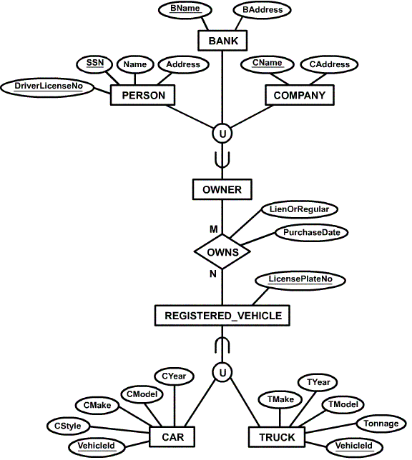
- specialization and generalization
- constraints

Specialization/generlization can be a lattice (multiple inheritance where STUDENT ASSISTANT inherits attributes of both EMPLOYEE and STUDENT):
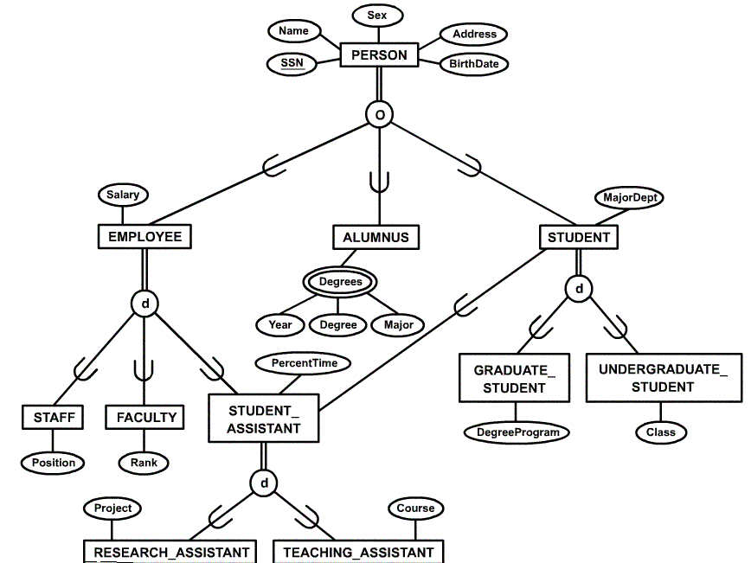

Workbench notation is closer to tables and UML than older ER

Can add layers
Can reverse engineer
(go from SQL definitions to ER)
(go from a live database to ER)

