Name______________________ MATH 213 Test 1 Makeup
February 25, 2009

- Consider the differential equation y” - 9y = 0. Find all constants r such that y = e^{rx} is a solution. Use this to write the general solution to the equation.

- For the following direction field,

- Identify (draw on graph) any equilibrium solutions and classify them as stable or unstable.
- Draw the solution through x(0) = 1 on the graph.
- Draw the phase portrait

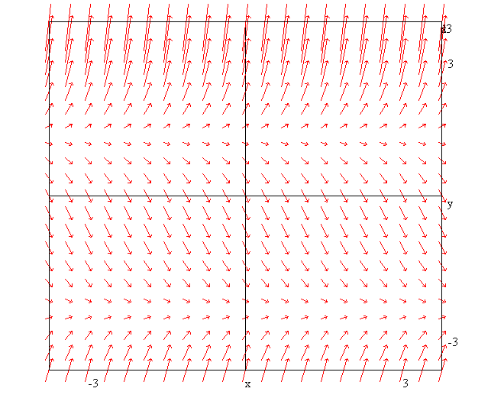

- Solve the following DEs
- (y² - 4)dx = x dy
- xy’ = 6x² - 3yx, y(0) = 4
- (3x²y² + cos x cos y)dx + (2x³y – sinx sin y + 7)dy = 0
- (xy + y²)dx – x² dy = 0
- y’/y = (xy³ - 1)
- y’+ xy – 1 = 0

- I am investing an initial amount of A₀ in a money market fund that pays 4% compounded continuously
- Determine a differential equation for A(t), the amount of money I will have at time t.
- Modify your equation to include withdrawals at the rate of $500 per year.
- Discuss the behaviour of my money over time. Does it depend on A₀?

- Explain/interpret the following equation from Dr. Kadera’s morning talk

r_{i}’ = α(r_{i} – m_{i})

Points per question

1 | 2 | 3 | 4 | 5 | Sum
8 | 10 | 72 | 8 | 5 | 103

