Name______________________ MATH 213 Test 1 Makeup
February 25, 2009

- Consider the differential equation y” - 9y = 0. Find all constants r such that y = e^{rx} is a solution. Use this to write the general solution to the equation.

y’ = r e^{rx}
y” = r² e^{rx}
y” - 9y = 0 becomes r² e^{rx} - 9e^{rx} = 0
(r² - 9)e^{rx} = 0
r = +/- 3

General solution: c₁ e^{3x} + c₂ e^{-3x}

- For the following direction field,

- Identify (draw on graph) any equilibrium solutions and classify them as stable or unstable.
- Draw the solution through x(0) = 1 on the graph.
- Draw the phase portrait
phase portrait

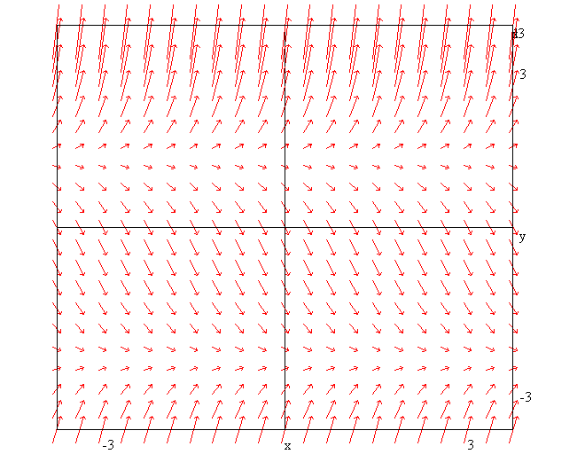
stable
unstable

- Solve the following DEs
- (y² - 4)dx = x dy (separable)

dx/x = dy/( y² - 4)
1/ (y² - 4) = A/(y-2) + B/(y+ 2)
1 = A(y+2) + B(y-2)
A+B = 0
1 = 2A -2B
A = ¼, B = -¼
ln|x|= ¼ln|y-2| - ¼ln|y+2| + c
x = c[(y-2)/(y+2)] ^{¼}
x⁴ = c[(y-2)/(y+2)]
... could solve for y

- xy’ = 6x² - 3yx, y(0) = 4
y’+ 3y = 6x (linear)
IF e^{3x}
(y e^{3x})’ = 6x e^{3x}
y e^{3x} = 2/3 e^{-3x} (3x - 1) + c (integrate by parts)
y = 2/3 (3x - 1) + c e^{-3x}
= 2x -2/3 + c e^{-3x}
Using y(0) = 4
4 = -2/3 + c
c = 4 2/3
y = 2x -2/3 + (4 2/3) e^{3x}

- (3x²y² + cos x cos y)dx + (2x³y – sinx sin y + 7)dy = 0
Exact:
M(x,y) = 3x²y² + cos x cos y
M_{y} = 6 x²y - cosx siny
N(x,y) = 2x³y – sinx sin y + 7
N_{x} = 6 x²y - cosx siny
∫M dx = 3x²y³ + sin x cos y
∫N dx = 3x²y³ + sin x cos y + 7y
Solution: 3x²y³ + sin x cos y + 7y = c

- (xy + y²)dx – x² dy = 0
Homogeneous, y = ux, dy = udx + x du
(ux² + u²x²)dx – x² (udx + x du) = 0
Cancel out an x²
(u + u²)dx – (udx + x du) = 0
(u+ u² –u)dx – x du = 0
u² dx – x du = 0
dx/x – du/ u² = 0
ln|x| + 1/u = c
ln|x| + x/y = c

- y’/y = (xy³ - 1)
y’ = (xy⁴ - y)
y’ + y = xy⁴ (Bernoulli)

- y’+ xy – 1 = 0
Integrating factor e$^{x2}$

(y e$^{x2}$)’ = e$^{x2}$
y e$^{x2}$ = ∫e$^{x2}$ + c (cannot be integrated, so leave as is)
y = e ⁻ $^{x2}$ ∫e$^{x2}$ + c e ⁻ $^{x2}$

- I am investing an initial amount of A₀ in a money market fund that pays 4% compounded continuously
- Determine a differential equation for A(t), the amount of money I will have at time t.
A’=.04A
A(t) = A₀e^{.04t}

- Modify your equation to include withdrawals at the rate of $500 per year.
A’=.04A – 500

- Discuss the behaviour of my money over time. Does it depend on A₀?

If you don’t start with enough to make up for the 500 each year, you will eventually have nothing left.
How much? enough so that you get 500 from interest. E.g.
.04 A₀ >500
A₀ > 500/.04 = 12,500
We can also figure this out from the critical point gotten by solving 04A – 500 = 0

- Explain/interpret the following equation from Dr. Kadera’s morning talk

r_{i}’ = α (r_{i} – m_{i})
growth is proportional to the amount of resources but negativley proportional to military spending
(spend ing on military decreases resources at a rate proportional to military spending

Points per question

1 | 2 | 3 | 4 | 5 | Sum
8 | 10 | 72 | 8 | 5 | 100

